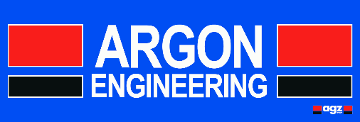

**Part of the AGZ Group**

Due to on-going growth we are currently looking to recruit for the following position to work within our subcontract engineering organisation. This is an exciting opportunity for the successful applicant to join our well-established engineering company.

**Mechanical Fitter/Supervisor**

The successful candidate must:-

* Be time served with a broad knowledge within an engineering environment.
* Be able to work on their own initiative and have excellent problem solving skills.
* Operate at all times within current quality and health and safety regulations/standards (ISO 9001 – OHSAS 18001)
* Possess a full UK driving licence.

You will possess a proven track record within a similar engineering environment, be able to work as part of a team and demonstrate good communication and leadership skills.

This is a dayshift roll with an excellent rate of pay which will be negotiable based on skills and experience. There is also opportunity to benefit from paid overtime in addition to the standard 39 hour week.

**Strictly no recruitment agencies or canvassers.**

Please send CV with a covering letter to:-

Mr Ben Cartwright

General Manager

Argon Engineering Ltd

Block 8, Unit 3

Chapelhall Industrial Estate

Airdrie

ML6 8QH

or

E-mail Ben at [ben@argon-eng.co.uk](mailto:ben@argon-eng.co.uk)